‘c’ ‘r’ ‘i’:
relu-lr0.003:
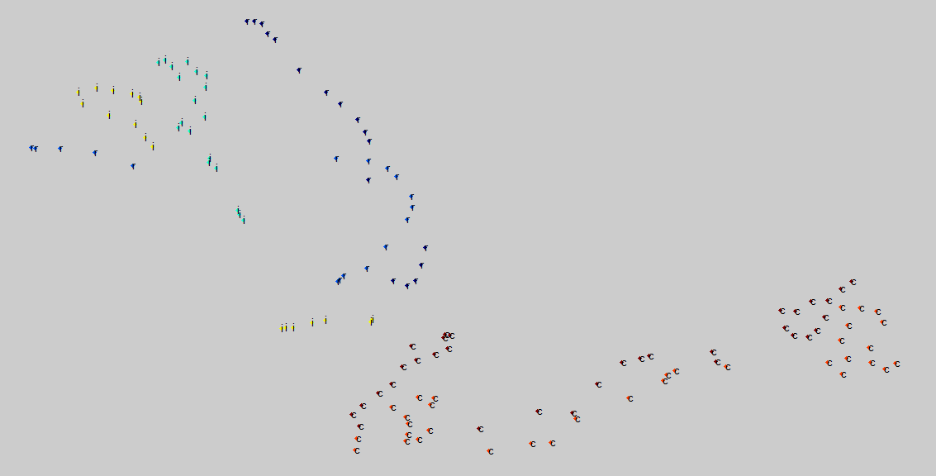
maxout-lr0.001-gs8:
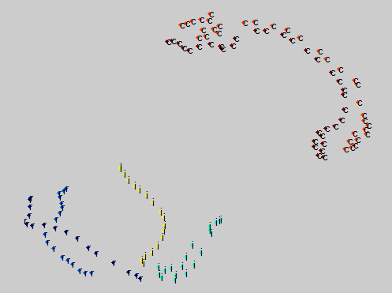
dropout-0.8:
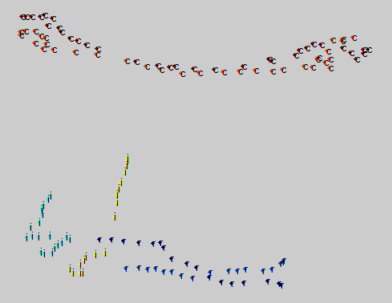

8-9utterance(6000 flames)
relu-lr0.003:
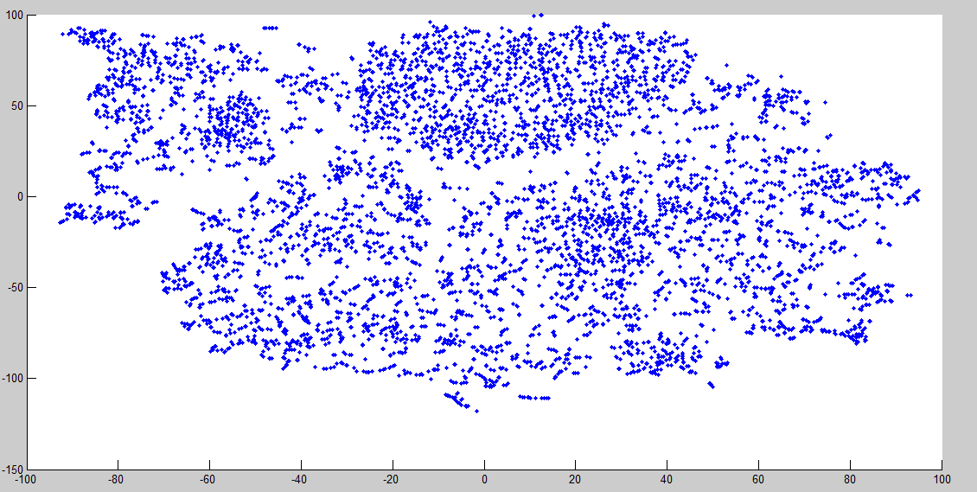
maxout-lr0.001-gs8:
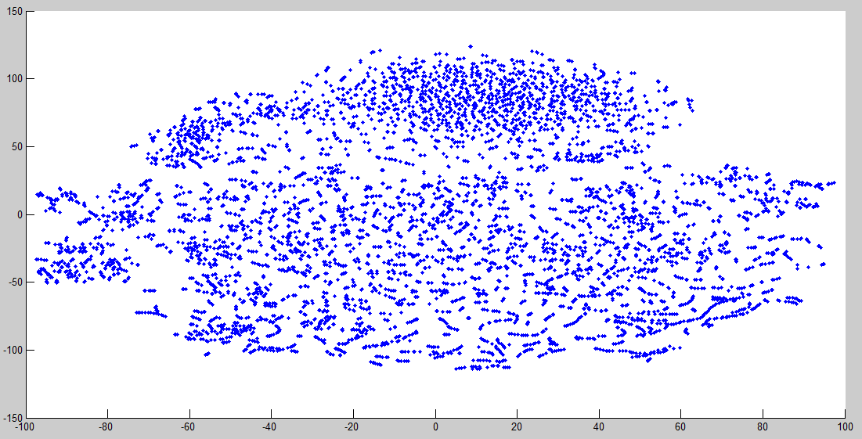
dropout-0.8:
